Day 40/100 – Understanding APIs & RESTful APIs

What is an API?
An API (Application Programming Interface) is a set of rules that allows one software application to communicate with another.
Think of an API as a messenger between two systems:
- You (client) send a request
- The API takes it to the server
- The server processes it
- The API brings back the response
API = Bridge between frontend and backend (or between two systems)

In real-world backend systems, APIs act as the communication layer between:
- Frontend (UI – Angular, React)
- Backend (Spring Boot, Node.js)
- Databases (PostgreSQL, MySQL)
- External services (payment gateways, maps, etc.)
Instead of accessing the database directly, the frontend always talks to the backend via APIs.
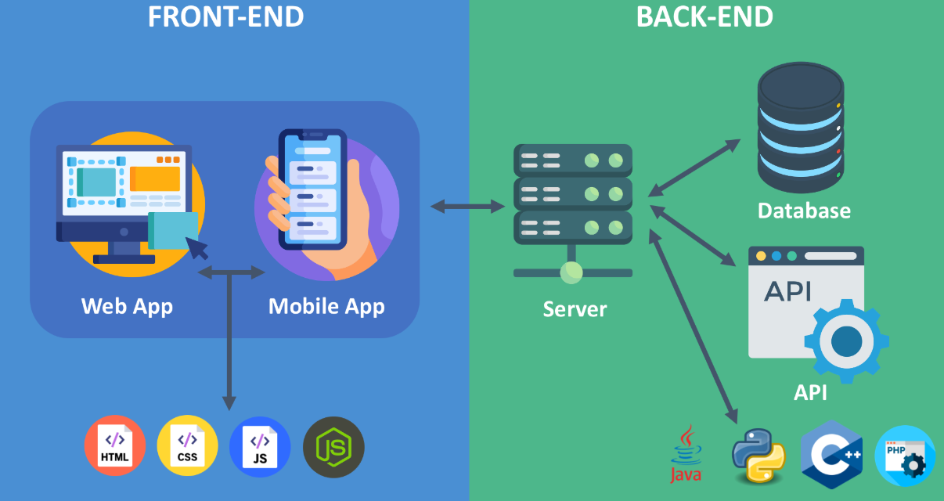
How API Works (Step-by-Step)
- Client (Frontend/Postman) sends a request
- API endpoint receives the request
- Backend processes logic (DB/API calls)
- Response is sent back (usually JSON)
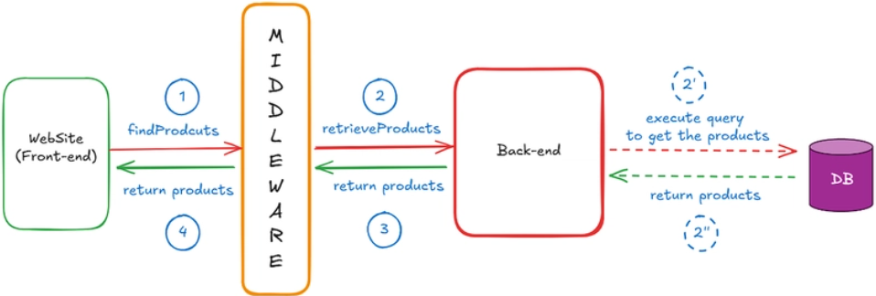
Real-Life Analogy
Imagine you're at a restaurant:
- You (client) → place an order
- Waiter (API) → takes request to kitchen
- Kitchen (server) → prepares food
- Waiter (API) → delivers response
You never interact directly with the kitchen.
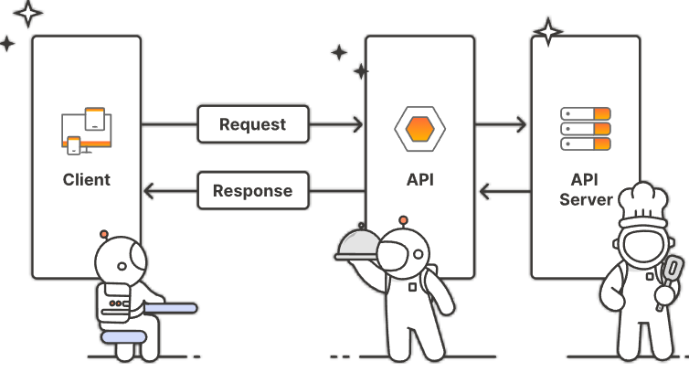

Example of an API
Let’s say you want user data:
Request:
GET /users/101
Response:

Here:
- /users/101 → endpoint
- GET → HTTP method
- JSON → response format

Angular → calls API
Spring Boot → exposes REST APIs
JPA → fetches data from DB

2. Types of APIs (Important for Interviews)
Type | Description | Example
Public API | Open to everyone | Google Maps API
Private API | Internal to company | Employee APIs
Partner API | Shared with partners | Payment gateway APIs
Composite API | Multiple calls in one | Dashboard APIs

3. HTTP Basics (Core Foundation)

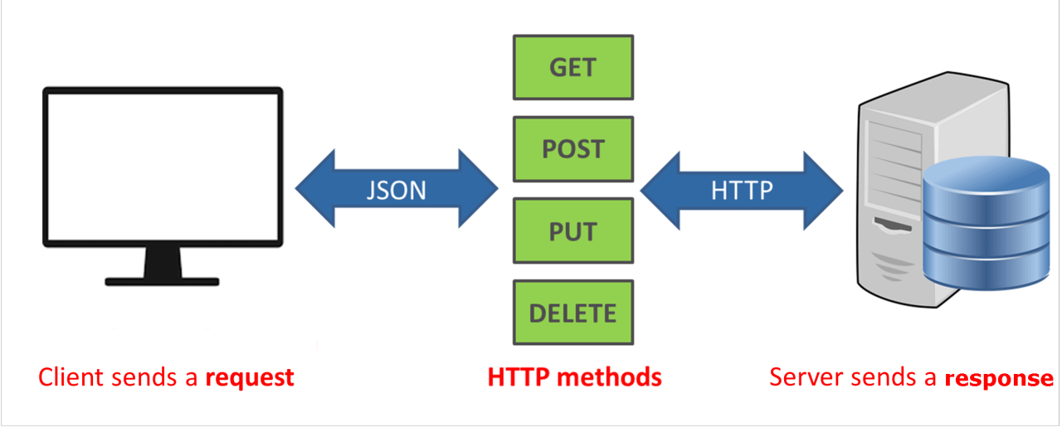
Method | Purpose | Example
GET | Fetch data | Get employees
POST | Create data | Add employee
PUT | Update full | Update employee
PATCH | Partial update | Update salary
DELETE | Remove | Delete employee

HTTP Status Codes
Code | Meaning
200 | Success
201 | Created
400 | Bad Request
401 | Unauthorized
404 | Not Found
500 | Server Error

Request Components
- URL → /employees/101
- Headers → Auth, Content-Type
- Body → JSON payload

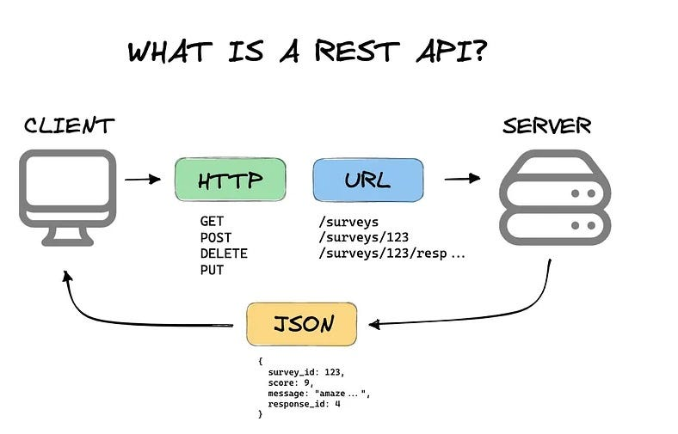
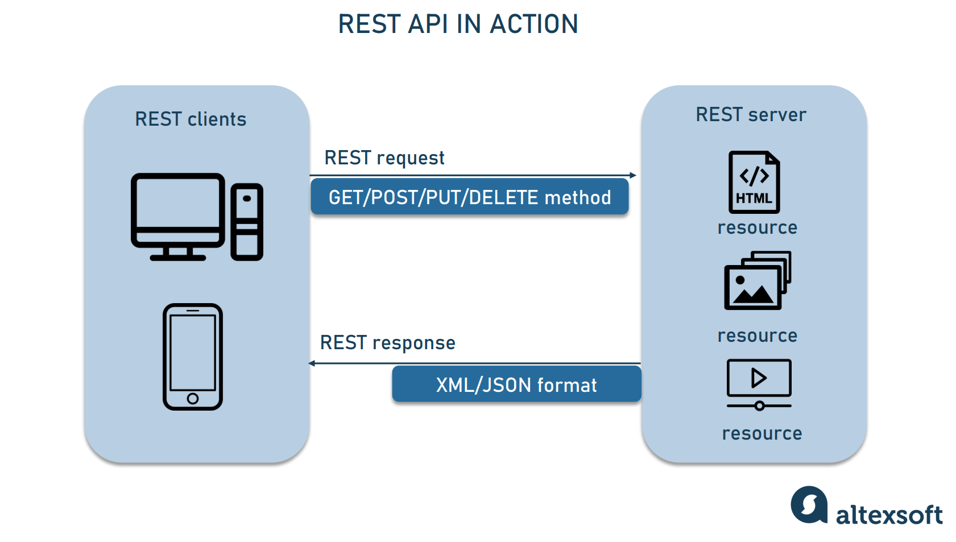

What Makes an API “RESTful”?
Using HTTP methods alone (GET, POST, PUT, DELETE) does NOT make an API RESTful.
A REST API is an API that follows the principles of REST (Representational State Transfer) architecture.
Key Principles of RESTful APIs
1. Resource-Based Design
Everything is treated as a resource (nouns, not verbs)
✅ Good:

❌ Bad:


2. Statelessness
Each request is independent.
- Server does NOT store client state
- Every request must contain all required information
- ❗ Server does NOT store client session data

Server doesn’t remember previous requests.

3.Standard HTTP Methods with Meaning
Method | Purpose
GET | Retrieve data
POST | Create new resource
PUT | Update entire resource
PATCH | Partial update
DELETE | Remove resource

4. Representation of Resources
Resources are returned in formats like:
- JSON (most common)
- XML
Example:


5. Proper Use of HTTP Status Codes
Code | Meaning
200 | Success
201 | Created
400 | Bad request
401 | Unauthorized
404 | Not found
500 | Server error

6.Layered Architecture
Client doesn’t know if it’s talking to:
- Actual server
- Proxy
- Load balancer
This improves scalability and security.


7.Uniform Interface (Most Important)
Consistency in:
- Endpoints
- Methods
- Responses
Example:
GET /users
GET /users/{id}
POST /users
DELETE /users/{id}

RESTful API Example
Create User
Request:

Response: 201 Created
Get User
Response:

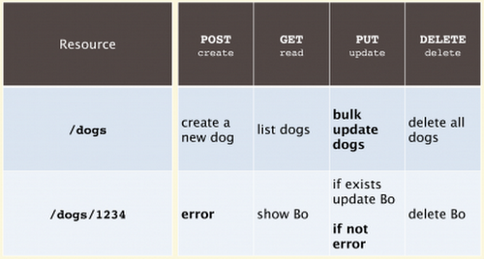

🎯 Employee API
Create Employee
POST /employees
Request:
{
"name": "Surya",
"role": "Backend Developer"
}
Response:
201 Created

Get Employee
GET /employees/101
Response:
{
"id": 101,
"name": "Surya",
"role": "Backend Developer"
}

- API = Communication bridge between systems
- RESTful API = API that follows REST principles
- REST is about:
  - Resources (not actions)
  - Stateless communication
  - Standardized structure
  - Proper HTTP usage
All RESTful APIs are APIs, but not all APIs are RESTful.
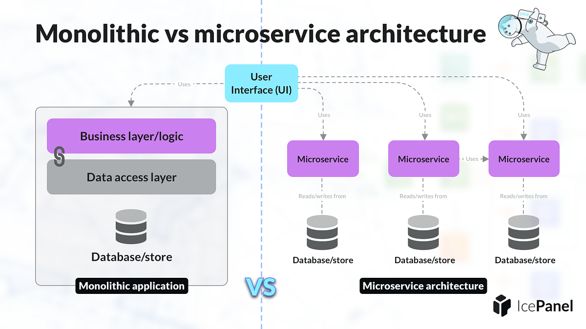
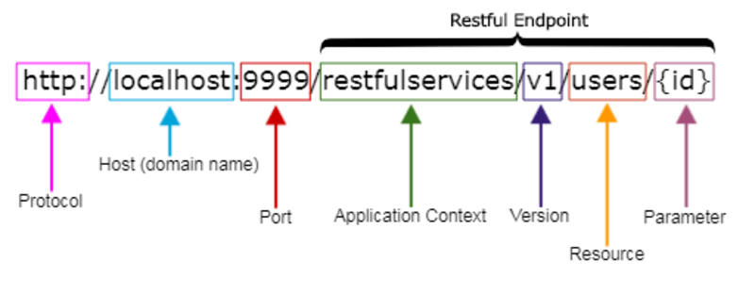


1. Layered Architecture
- Controller → Handles API
- Service → Business logic
- Repository → DB access
2. Use DTOs (Data Transfer Objects)
Avoid exposing entities directly.
3. Validation
Use validations:
- Required fields
- Formats
- Constraints
4. Exception Handling
Global exception handler:
- Clean error messages
- Proper status codes
5. Authentication & Authorization
- JWT tokens
- Role-based access
6. API Versioning
/api/v1/employees
/api/v2/employees
7. Clean Naming Conventions
- Use plural nouns → /employees
- Avoid verbs → /getEmployees
8. Tools Used in Real Projects
- Postman → API testing
- Swagger → API documentation
- Spring Boot → Backend APIs
- Angular → UI calling APIs
- PostgreSQL → Database

- API = Communication bridge
- REST = Architectural style
- RESTful API = API following REST principles
- Focus areas for interviews:
  - Statelessness
  - Resource-based design
  - HTTP methods & status codes
  - Backend layering

API & REST – Interview Q&A + Spring Boot Template (Job-Ready)

1. What is an API?
An API (Application Programming Interface) allows different software systems to communicate using defined rules (request–response model).

2. What is a REST API?
A REST API follows REST principles like statelessness, resource-based design, and standard HTTP methods.

3. Difference: API vs REST API?
API | REST API
General concept | Specific architecture
Can use any protocol | Uses HTTP
No strict rules | Follows REST constraints

4. What makes an API RESTful?
- Stateless
- Uses HTTP methods properly
- Resource-based URLs
- Proper status codes
- Uniform interface

5. What is Statelessness?
Each request is independent; server does not store client session.

6. HTTP Methods?
- GET → Fetch
- POST → Create
- PUT → Update full
- PATCH → Partial update
- DELETE → Remove

7. PUT vs PATCH?
PUT | PATCH
Full update | Partial update
Replaces resource | Modifies fields
8. What are HTTP Status Codes?
Standard response indicators (200, 201, 404, 500, etc.)

9. What is Idempotency?
Calling an API multiple times gives same result.
- GET → idempotent
- PUT → idempotent
- POST → not idempotent

10. What is an Endpoint?
A specific URL where API is accessed.
Example: /employees/101

11. What is JSON?
Lightweight data format used in APIs.

12. What are Headers?
Metadata of request (Auth token, Content-Type)

13. What is Authentication vs Authorization?
Authentication | Authorization
Who are you? | What can you access?

14. What is JWT?
JSON Web Token used for secure authentication.

15. What is Rate Limiting?
Restricting number of API calls to prevent abuse.

16. What is API Versioning?
Maintaining multiple API versions.
Example:
/api/v1/users
/api/v2/users
17. What is HATEOAS? (Advanced)
API provides links for next actions.

18. What is Caching?
Storing responses to improve performance.

19. What is a 3-Tier Architecture?
- Controller
- Service
- Repository

20. Best Practices in API Design?
- Use nouns (not verbs)
- Proper status codes
- Validation
- Exception handling
- Secure APIs

PART 2: Spring Boot REST API Code Template (Production Style)
Using:
- Spring Boot
- Spring Data JPA
- PostgreSQL

1. Entity Layer
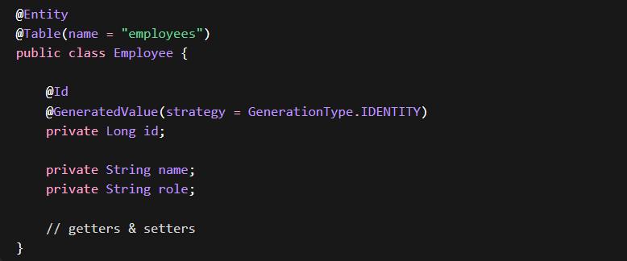

2. Repository Layer


3. DTO (Best Practice)


4. Service Layer
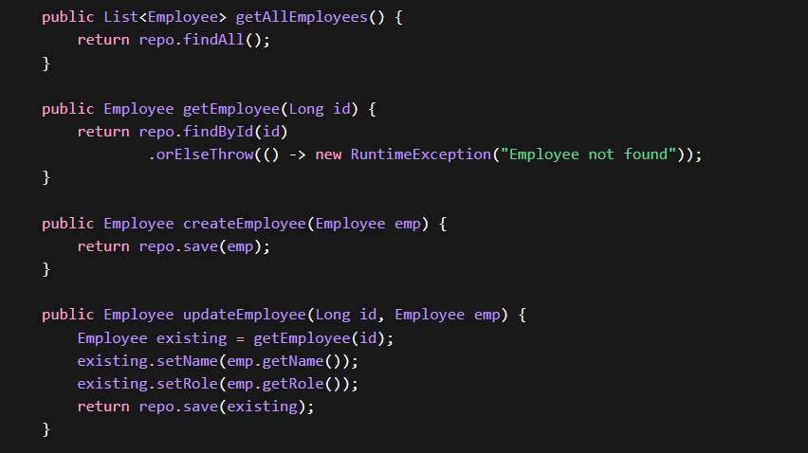
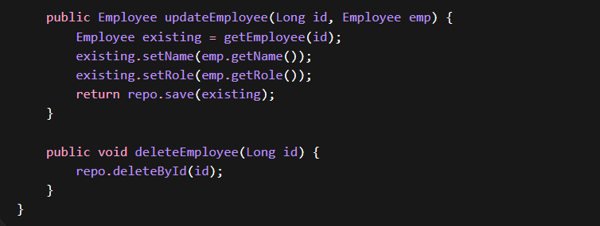

5. Controller Layer
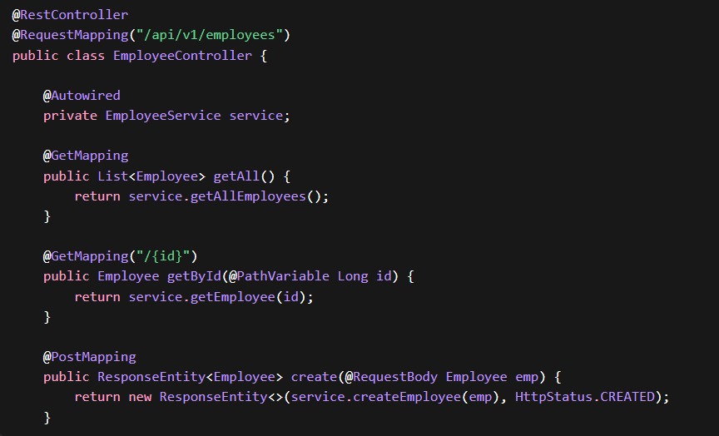
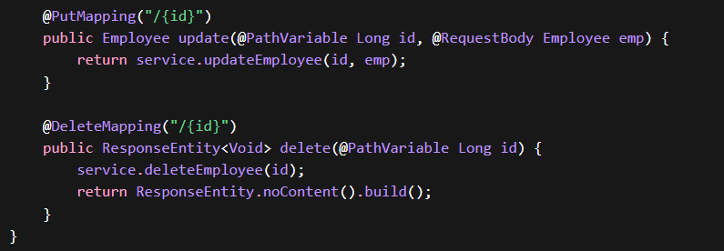

6. Global Exception Handler (Important)
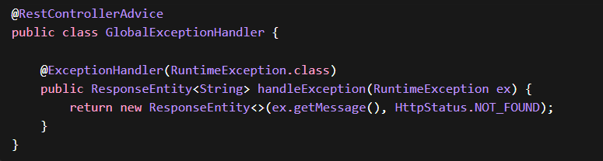

7. application.properties
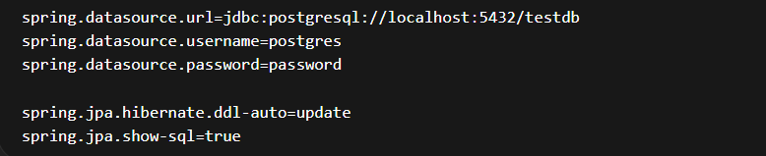
🧠 How to Explain This in Interview (2-Min Answer)
“I design REST APIs using layered architecture—Controller, Service, Repository.
I follow REST principles like statelessness and resource-based URLs.
I use proper HTTP methods, DTOs for clean data transfer, and global exception handling.
I also ensure validation, security (JWT), and scalable design.”

